SQL is a language to operate databases; it includes database creation, deletion, fetching rows, modifying rows, etc. SQL is an ANSI (American National Standards Institute) standard language, but there are many different versions of the SQL language.

What is SQL?
SQL is Structured Query Language, which is a computer language for storing, manipulating and retrieving data stored in a relational database.
SQL is the standard language for Relational Database System. All the Relational Database Management Systems (RDMS) like MySQL, MS Access, Oracle, Sybase, Informix, Postgres and SQL Server use SQL as their standard database language.
Also, they are using different dialects, such as −
- MS SQL Server using T-SQL,
- Oracle using PL/SQL,
- MS Access version of SQL is called JET SQL (native format) etc.

Why SQL?
SQL is widely popular because it offers the following advantages −
- Allows users to access data in the relational database management systems.
- Allows users to describe the data.
- Allows users to define the data in a database and manipulate that data.
- Allows to embed within other languages using SQL modules, libraries & pre-compilers.
- Allows users to create and drop databases and tables.
- Allows users to create view, stored procedure, functions in a database.
- Allows users to set permissions on tables, procedures and views.

A Brief History of SQL
- 1970 − Dr. Edgar F. "Ted" Codd of IBM is known as the father of relational databases. He described a relational model for databases.
- 1974 − Structured Query Language appeared.
- 1978 − IBM worked to develop Codd's ideas and released a product named System/R.
- 1986 − IBM developed the first prototype of relational database and standardized by ANSI. The first relational database was released by Relational Software which later came to be known as Oracle.

SQL Process
When you are executing an SQL command for any RDBMS, the system determines the best way to carry out your request and SQL engine figures out how to interpret the task.
There are various components included in this process.
These components are −
- Query Dispatcher
- Optimization Engines
- Classic Query Engine
- SQL Query Engine, etc.
A classic query engine handles all the non-SQL queries, but a SQL query engine won't handle logical files.
Following is a simple diagram showing the SQL Architecture −
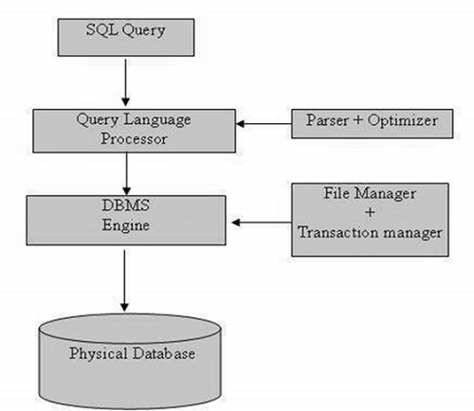

SQL Data Types
Data types are used to represent the nature of the data that can be stored in the database table. For example, in a particular column of a table, if we want to store a string type of data then we will have to declare a string data type of this column.
Data types mainly classified into three categories for every database.
- String Data types
- Numeric Data types
- Date and time Data types

Data Types in MySQL, SQL Server and Oracle Databases

MySQL Data Types
A list of data types used in MySQL database. This is based on MySQL 8.0.
MySQL String Data Types
CHAR(Size) | It is used to specify a fixed length string that can contain numbers, letters, and special characters. Its size can be 0 to 255 characters. Default is 1.
VARCHAR(Size) | It is used to specify a variable length string that can contain numbers, letters, and special characters. Its size can be from 0 to 65535 characters.
BINARY(Size) | It is equal to CHAR() but stores binary byte strings. Its size parameter specifies the column length in the bytes. Default is 1.
VARBINARY(Size) | It is equal to VARCHAR() but stores binary byte strings. Its size parameter specifies the maximum column length in bytes.
TEXT(Size) | It holds a string that can contain a maximum length of 255 characters.
TINYTEXT | It holds a string with a maximum length of 255 characters.
MEDIUMTEXT | It holds a string with a maximum length of 16,777,215.
LONGTEXT | It holds a string with a maximum length of 4,294,967,295 characters.
ENUM(val1, val2, val3,...) | It is used when a string object having only one value, chosen from a list of possible values. It contains 65535 values in an ENUM list. If you insert a value that is not in the list, a blank value will be inserted.
SET( val1,val2,val3,....) | It is used to specify a string that can have 0 or more values, chosen from a list of possible values. You can list up to 64 values at one time in a SET list.
BLOB(size) | It is used for BLOBs (Binary Large Objects). It can hold up to 65,535 bytes.
MySQL Numeric Data Types
BIT(Size) | It is used for a bit-value type. The number of bits per value is specified in size. Its size can be 1 to 64. The default value is 1.
INT(size) | It is used for the integer value. Its signed range varies from -2147483648 to 2147483647 and unsigned range varies from 0 to 4294967295. The size parameter specifies the max display width that is 255.
INTEGER(size) | It is equal to INT(size).
FLOAT(size, d) | It is used to specify a floating point number. Its size parameter specifies the total number of digits. The number of digits after the decimal point is specified by d parameter.
FLOAT(p) | It is used to specify a floating point number. MySQL used p parameter to determine whether to use FLOAT or DOUBLE. If p is between 0 to24, the data type becomes FLOAT (). If p is from 25 to 53, the data type becomes DOUBLE().
DOUBLE(size, d) | It is a normal size floating point number. Its size parameter specifies the total number of digits. The number of digits after the decimal is specified by d parameter.
DECIMAL(size, d) | It is used to specify a fixed point number. Its size parameter specifies the total number of digits. The number of digits after the decimal parameter is specified by d parameter. The maximum value for the size is 65, and the default value is 10. The maximum value for d is 30, and the default value is 0.
DEC(size, d) | It is equal to DECIMAL(size, d).
BOOL | It is used to specify Boolean values true and false. Zero is considered as false, and nonzero values are considered as true.
MySQL Date and Time Data Types
DATE | It is used to specify date format YYYY-MM-DD. Its supported range is from '1000-01-01' to '9999-12-31'.
DATETIME(fsp) | It is used to specify date and time combination. Its format is YYYY-MM-DD hh:mm:ss. Its supported range is from '1000-01-01 00:00:00' to 9999-12-31 23:59:59'.
TIMESTAMP(fsp) | It is used to specify the timestamp. Its value is stored as the number of seconds since the Unix epoch('1970-01-01 00:00:00' UTC). Its format is YYYY-MM-DD hh:mm:ss. Its supported range is from '1970-01-01 00:00:01' UTC to '2038-01-09 03:14:07' UTC.
TIME(fsp) | It is used to specify the time format. Its format is hh:mm:ss. Its supported range is from '-838:59:59' to '838:59:59'
YEAR | It is used to specify a year in four-digit format. Values allowed in four digit format from 1901 to 2155, and 0000.

SQL Server Data Types
SQL Server String Data Type
char(n) | It is a fixed width character string data type. Its size can be up to 8000 characters.
varchar(n) | It is a variable width character string data type. Its size can be up to 8000 characters.
varchar(max) | It is a variable width character string data types. Its size can be up to 1,073,741,824 characters.
text | It is a variable width character string data type. Its size can be up to 2GB of text data.
nchar | It is a fixed width Unicode string data type. Its size can be up to 4000 characters.
nvarchar | It is a variable width Unicode string data type. Its size can be up to 4000 characters.
ntext | It is a variable width Unicode string data type. Its size can be up to 2GB of text data.
binary(n) | It is a fixed width Binary string data type. Its size can be up to 8000 bytes.
varbinary | It is a variable width Binary string data type. Its size can be up to 8000 bytes.
image | It is also a variable width Binary string data type. Its size can be up to 2GB.
SQL Server Numeric Data Types
bit | It is an integer that can be 0, 1 or null.
tinyint | It allows whole numbers from 0 to 255.
Smallint | It allows whole numbers between -32,768 and 32,767.
Int | It allows whole numbers between -2,147,483,648 and 2,147,483,647.
bigint | It allows whole numbers between -9,223,372,036,854,775,808 and 9,223,372,036,854,775,807.
float(n) | It is used to specify floating precision number data from -1.79E+308 to 1.79E+308. The n parameter indicates whether the field should hold the 4 or 8 bytes. Default value of n is 53.
real | It is a floating precision number data from -3.40E+38 to 3.40E+38.
money | It is used to specify monetary data from -922,337,233,685,477.5808 to 922,337,203,685,477.5807.
SQL Server Date and Time Data Type
datetime | It is used to specify date and time combination. It supports range from January 1, 1753, to December 31, 9999 with an accuracy of 3.33 milliseconds.
datetime2 | It is used to specify date and time combination. It supports range from January 1, 0001 to December 31, 9999 with an accuracy of 100 nanoseconds
date | It is used to store date only. It supports range from January 1, 0001 to December 31, 9999
time | It stores time only to an accuracy of 100 nanoseconds
timestamp | It stores a unique number when a new row gets created or modified. The time stamp value is based upon an internal clock and does not correspond to real time. Each table may contain only one-time stamp variable.
SQL Server Other Data Types
Sql_variant | It is used for various data types except for text, timestamp, and ntext. It stores up to 8000 bytes of data.
XML | It stores XML formatted data. Maximum 2GB.
cursor | It stores a reference to a cursor used for database operations.
table | It stores result set for later processing.
Unique identifier | It stores GUID (Globally unique identifier).

Oracle Data Types
Oracle String data types
CHAR(size) | It is used to store character data within the predefined length. It can be stored up to 2000 bytes.
NCHAR(size) | It is used to store national character data within the predefined length. It can be stored up to 2000 bytes.
VARCHAR2(size) | It is used to store variable string data within the predefined length. It can be stored up to 4000 byte.
VARCHAR(SIZE) | It is the same as VARCHAR2(size). You can also use VARCHAR(size), but it is suggested to use VARCHAR2(size)
NVARCHAR2(size) | It is used to store Unicode string data within the predefined length. We have to must specify the size of NVARCHAR2 data type. It can be stored up to 4000 bytes.
Oracle Numeric Data Types
NUMBER(p, s) | It contains precision p and scale s. The precision p can range from 1 to 38, and the scale s can range from -84 to 127.
FLOAT(p) | It is a subtype of the NUMBER data type. The precision p can range from 1 to 126.
BINARY_FLOAT | It is used for binary precision( 32-bit). It requires 5 bytes, including length byte.
BINARY_DOUBLE | It is used for double binary precision (64-bit). It requires 9 bytes, including length byte.
Oracle Date and Time Data Types
DATE | It is used to store a valid date-time format with a fixed length. Its range varies from January 1, 4712 BC to December 31, 9999 AD.
TIMESTAMP | It is used to store the valid date in YYYY-MM-DD with time hh:mm:ss format.
Oracle Large Object Data Types (LOB Types)
BLOB | It is used to specify unstructured binary data. Its range goes up to 2³²-1 bytes or 4 GB.
BFILE | It is used to store binary data in an external file. Its range goes up to 2³²-1 bytes or 4 GB.
CLOB | It is used for single-byte character data. Its range goes up to 2³²-1 bytes or 4 GB.
NCLOB | It is used to specify single byte or fixed length multibyte national character set (NCHAR) data. Its range is up to 2³²-1 bytes or 4 GB.
RAW(size) | It is used to specify variable length raw binary data. Its range is up to 2000 bytes per row. Its maximum size must be specified.
LONG RAW | It is used to specify variable length raw binary data. Its range up to 2³¹-1 bytes or 2 GB, per row.

SQL Commands
- SQL commands are instructions. It is used to communicate with the database. It is also used to perform specific tasks, functions, and queries of data.
- SQL can perform various tasks like create a table, add data to tables, drop the table, modify the table, set permission for users.

Types of SQL Commands
There are five types of SQL commands: DDL, DML, DCL, TCL, and DQL.
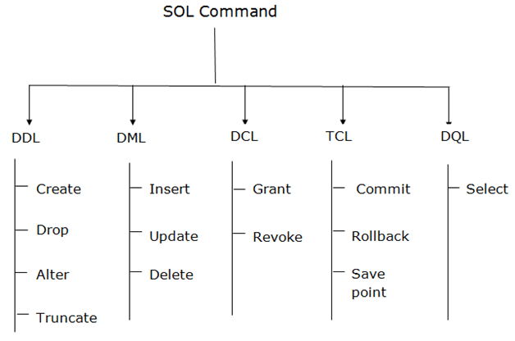

1. Data Definition Language (DDL)
- DDL changes the structure of the table like creating a table, deleting a table, altering a table, etc.
- All the command of DDL are auto-committed that means it permanently save all the changes in the database.
Here are some commands that come under DDL:
- CREATE
- ALTER
- DROP
- TRUNCATE

2. Data Manipulation Language
- DML commands are used to modify the database. It is responsible for all form of changes in the database.
- The command of DML is not auto-committed that means it can't permanently save all the changes in the database. They can be rollback.
Here are some commands that come under DML:
- INSERT
- UPDATE
- DELETE

3. Data Control Language
DCL commands are used to grant and take back authority from any database user.
Here are some commands that come under DCL:
- Grant
- Revoke

4. Transaction Control Language
TCL commands can only use with DML commands like INSERT, DELETE and UPDATE only.
These operations are automatically committed in the database that's why they cannot be used while creating tables or dropping them.
Here are some commands that come under TCL:
- COMMIT
- ROLLBACK
- SAVEPOINT

5. Data Query Language
DQL is used to fetch the data from the database.
It uses only one command:
- SELECT

